Dear Applicant,

Thank you for your enquiry about the post of Chef. We are looking for a reliable and enthusiastic individual to join our team. Various hours and shifts are available.

A little about us: The Maltings has operated as an arts and community centre for Farnham since the early 70s. There is a core of successful activities – a contemporary theatre programme, film and satellite broadcasts, music and comedy events and a flourishing craft festival programme. We have a flexible Great Hall which can be set as a 240 or 400 seated performance space or 500 standing. We also have a 100 studio and range of other spaces used for small concerts, etc.
We are a well-used and popular set of buildings – over 400,000 people attend each year - we have strong and supportive relationships with Arts Council and our Local Authorities, funding agreements in place until 2023, a hugely capable staff team and a financially resilient business model.
However, the last 16 months have thrown up unprecedented challenges. We closed for a most of last year, opened, closed again and are now starting to reopen. Everyone has had to adapt, respond to new opportunities, make the best of our resources, work collaboratively and remain confident in our ability to contribute to the quality of people’s lives across the town.
Hopefully the attached job description will give you a good sense of the main duties of this post. However, if you want an informal conversation about the post feel free to call Paula, Bar & Catering Manager, on 01252 745450.
If you wish to apply, please forward a CV and covering letter to recruitment@farnhammaltings.com.
Good luck!
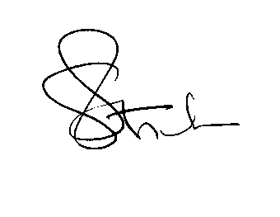
gavin stride
Director

