On the town
Awards of £2000-£7000 to seed a new piece of theatre
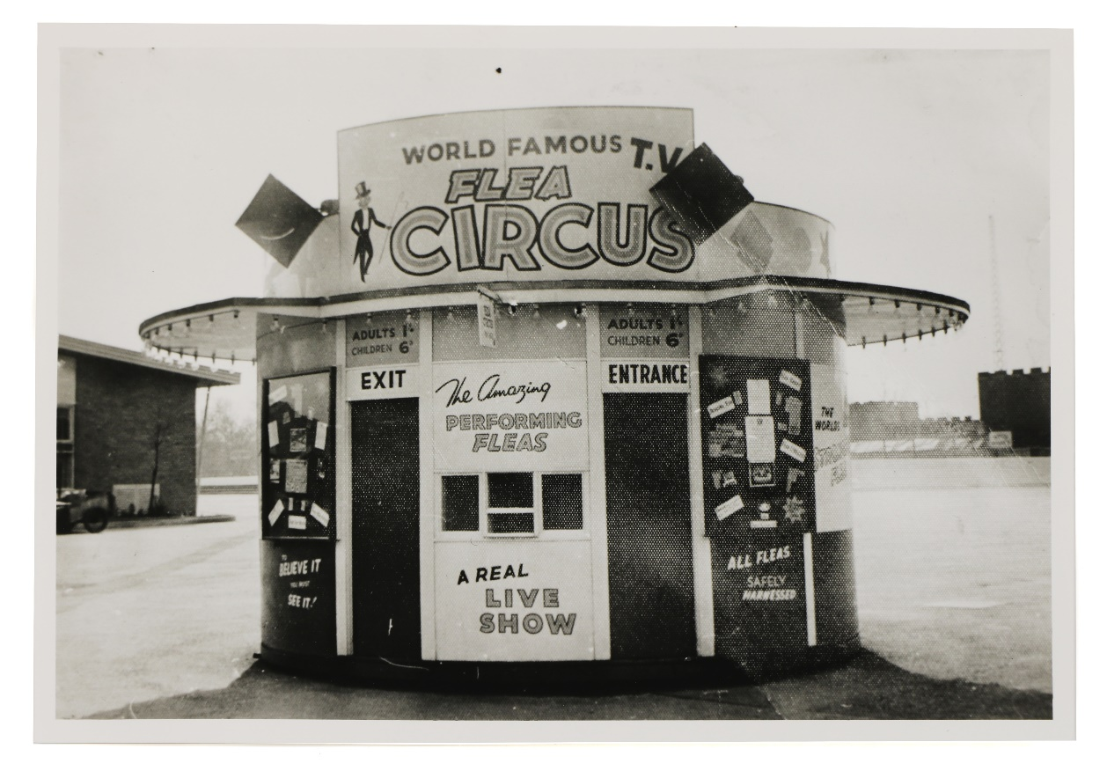
We want to support arts venues in our South East towns to create new popular theatre experiences for their town, in their community and importantly, outside of their venue.
The South East is made up of more small towns than any other region. From coastal and semi-rural to more urban areas on the edge of our cities, some are historic market towns, others new towns with new names. They are part of our character; they shape the way we live and are often overlooked by powerful metropolitan and rural interests.

We are looking to invest in the production of new work which connects with those who may not regularly engage with theatre in our towns, work that is enticing and relevant and work that plays with new forms.
This might encompass site-specific work or theatre that doesn’t look like theatre; it might be based in variety, comedy, magic or maybe roller skating!
The work could take place in market squares, care homes, cafes or swimming pools, but it should be work that brings a little joy and can rekindle an appetite for contemporary, popular entertainment.
We are looking to make a small number of investments of £2000-£7000 to seed ideas for new work that seeks to achieve these ambitions.
Longer term we’d hope to support the most successful of these projects, alongside the producing venue to visit further town locations across the South East.

Applicants
We expect lead applicants to be arts venues, libraries or museums partnering with an artist or company. It maybe that an idea includes working with less traditional partners such as football clubs, walking groups, playgroups or hairdressers.
We’re particularly interested to hear from new venue and artist partnerships and from some of our smaller venues who may be new to producing this type of project.

Making a proposal
Visit http://theatre.farnhammaltings.com/portfolio/new-popular/ for more information and to download the proposal form.
All proposals should be accompanied with an outline budget and submitted by email to: katy.potter@farnhammaltings.com
Closing date for submissions is 9am Wednesday 13 April 2022
Applicants will be notified of the outcome of their application by Friday 6 May 2022
Proposals will be selected by a small curatorial panel and decisions will be based on:
- the artistic idea
- the approach to engaging new audiences, both its practicality and authenticity
- the depth of the partnership and how far the project supports mutual ambitions

About Us
Farnham Maltings was established as an arts centre in 1969. Over the past 18 years the organisation has repositioned itself as a regional development organisation working across South East England. As a National Portfolio Organisation, Farnham Maltings runs a programme of work designed to increase the range, quality and audience for theatre across the south east region, has established a network of 180 venues who jointly programme and support a south east regional ecology, creates work for village halls, produces a cohort of the regions’ most promising talent and leads a national programme to internationalise the independent theatre sector in partnership with the British Council and UKTI.
New Popular is a five year initiative supported by Esmee Fairbairn Foundation designed to test and create new theatre projects with the ambition of reaching broader audiences in new places with new experiences.

Get in touch
If you would like to talk though your idea with us at any stage, we would welcome that conversation; contact Katy Potter, Producer Mon-Thurs to arrange a call. katy.potter@farnhammaltings.co.uk

